Game Design Document

Fill up the following document

1. Write the title of your project.

Running home

1. What is the goal of the game?

Llegar a casa

1. Write a brief story of your game.

Alex es un niño que se perdio en el bosque y tiene que encontrar un

Camino de regreso a casa

1. Which are the playing characters of this game?

* Playing characters are the ones who respond to the user based on the input from the user.
* Cars, monkeys, dinos, wizards, etc., are the playing characters in the game.

|  |  |  |
| --- | --- | --- |
| Number | Character Name | What can this character do? |
| 1 | Alex | protagonista |
| 2 | Monster | Hacechador del bosque |
| 3 | Montañosta loco | Hacechador de las montañas |
| 4 | cabras | Trampas de las montañas |
| 5 | sacerdotes | Hacechadores de las ruinas |
| 6 | delincuentes | Hacechadores de la ciudad |
| 7 | coches | Trampas de la ciudad |
| 8 | locura | Jefe final |

1. Which are the Non-Playing Characters of this game?

* Non-Playing characters are the ones that don't have an action or behavior when the user interacts with the game.
* Hurdles, stones, bananas, coins, etc., are non-playing characters in the game.

|  |  |  |
| --- | --- | --- |
| Number | Character Name | What can this character do? |
| 1 | guardabosques | Aparece en el bosque |
| 2 | rocas | Estructura de las montañas |
| 3 | Arboles | Estructura del bosque |
| 4 | trampas | Aparecen en las ruinas |
| 5 | edificios | Estructura de la ciudad |
| 6 | casa | Objetivo final |
| 7 | Padres | Contemplan la batalla final |
| 8 | alma | Defender en la batalla final |

Draw your imagination of this game. What does this game look like?

* Draw the game either on your computer or on paper.
* Add images of the game scenes to show each of the playing and non-playing characters at least once. 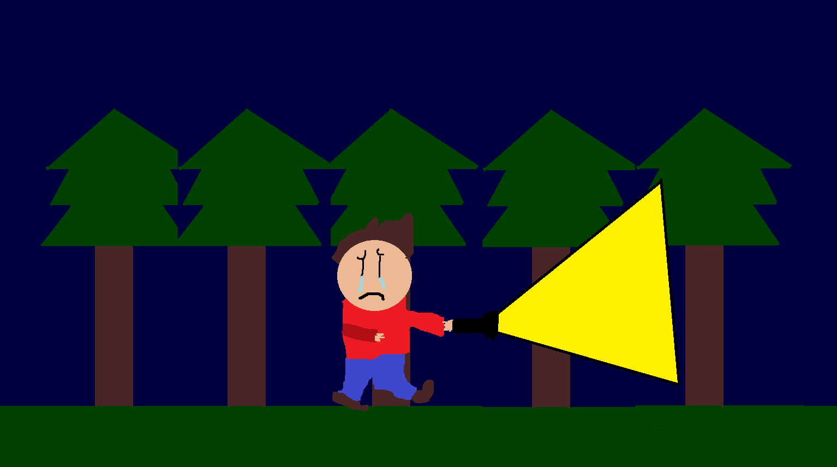

How do you plan to make your game engaging?

No, no lo hago pero no habria nada de malo si lo fuera